Shop-Nest Store Analysis report

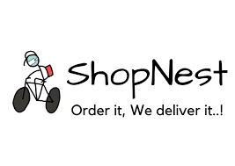

Shop-Nest, a leading department store in Portugal's e-commerce marketplace, plays a pivotal role in connecting small businesses from various regions across the country to a broader market. By serving as a seamless link, Shop-Nest enables merchants to showcase and sell their products efficiently through its platform, with the added convenience of direct shipment facilitated by Shop-Nest’s logistics partners.

This capstone project involves designing a comprehensive Power BI dashboard to analyze key business metrics and uncover insights from Shop-Nest’s anonymized commercial data. The project encompasses several analytical tasks, aimed at enhancing our understanding of sales performance, customer behaviour, and operational efficiency.

The provided datasets cover various aspects of Shop-Nest’s operations, including customer information, geolocation data, order items, payments, reviews, product details, sellers, and product categories. By integrating and analyzing these datasets, the Power BI dashboard addresses the following critical business questions:

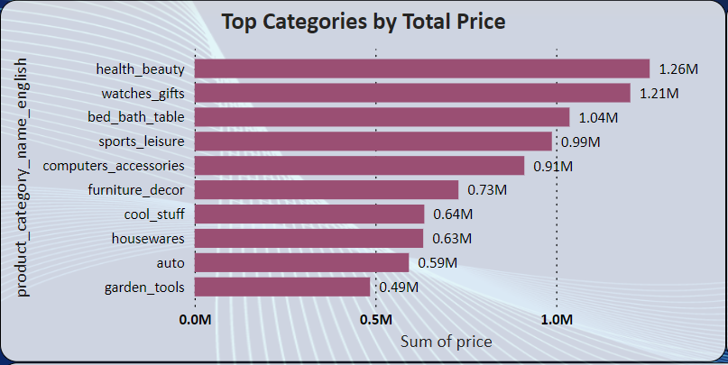**Top Categories by Total Price**

This bar chart provides a clear representation of the top 10 Product Categories by Total Sales. The data highlights the product Categories that generates the most revenue for Shop-Nest.

**Key-Insights**

* **Top-Performers** – The chart shows that categories such as ‘Health_beauty’, ’watches_gifts’ and ‘bed_bath_table’ are top 3 revenue generators.
* **Trends and patterns** – The data reveals that certain categories consistently perform throughout the year, while others have seasonal peaks.

**Business Implications**

* **Inventory Management** – With a clear understanding of the top categories, Shop-Nest can optimize inventory levels to meet demand, reducing the risk of stockouts or overstock situation.
* **Strategic Decision Making** – Strategic decision-making processes such as, resource allocation, marketing strategies, inventory management, and product development initiatives are essential for optimizing sales performance.

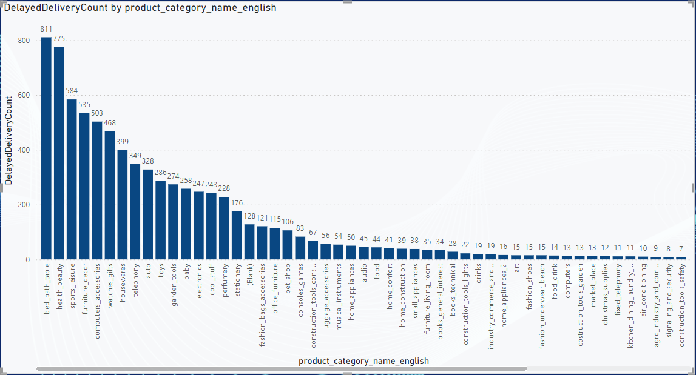**Delayed Order Analysis**

This visualization presents the number of delayed orders across various product categories. An order is classified as delayed if the actual delivery date surpasses the estimated delivery date.

**Key-Insights**

* **High delay Categories** – The chart reveals that ‘bed_bath_table’ has the highest number which is 811 has the highest delay due to supply chain complexities or bulkier item require more careful handling.
* **Comparative Analysis** – Comparing the delays rates across different Categories can help identify which product lines are more prone to delivery issues.

**Business Implications**

* **Logistics Optimization** – Understanding which categories face more delays can help Shop-Nest focus on optimizing logistics for these products.
* **Inventory Management** – Increase buffer stock for high delay categories to mitigate the impact of supply chain disruptions.

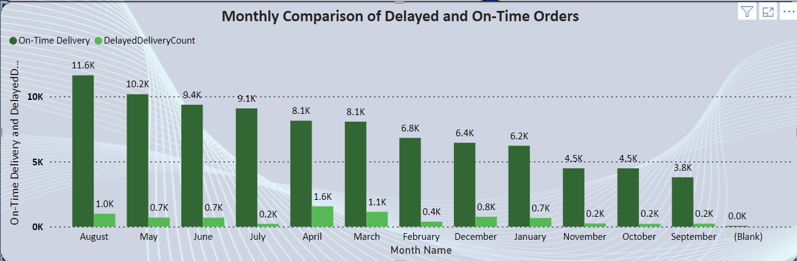**Monthly Comparison of On-Time and Delayed Orders**

The Monthly comparison of On-Time and Delayed Orders is represented in clustered column chart. This visual provides a clear month-by-month breakdown of the performance in terms of delivery punctuality.

**Key-Insights**

* **Monthly Delayed Delivery Trend** – April and March month appear to have the highest counts of delayed deliveries, indicating potential issues or challenges during this period.
* **Monthly On-Time Delivery** – August and May month appear to be the highest count of On-Time deliveries, suggesting a balance performance despite challenges.
* **Seasonal Trends** – The visual helps identify any Seasonal trends in delivery performance. For instance, an increase in delayed orders during certain months might indicate higher order volumes or potential issues in the supply chain.

By regularly Monitoring the visual, Shop-Nest can proactively manage its logistics and improve customer satisfaction by minimizing delivery delays, the detailed Drill through analysis further allows for a granular look into specific problem areas, enabling targeted improvements.

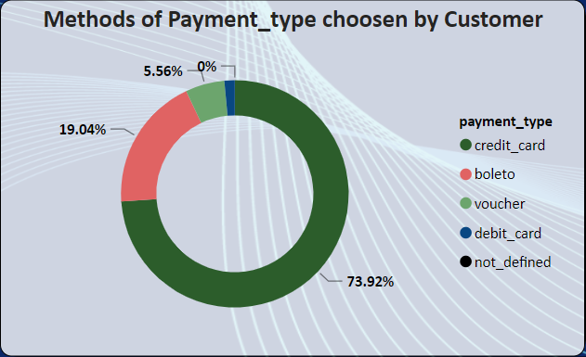**Payment Method Analysis**

The analysis of payment methods is represented through a pie chart, providing a clear visual breakdown of the most frequently used payment methods by customers.

**Key-Insights**

* **Most Used Payment Method** – The pie chart helps identify that ‘Credit Card’ payment method are most popular among customers. This can indicate customer preferences and potentially inform strategic decisions around payment options. The payment method that is used most frequently, which might indicate customer trust and satisfaction with that method.
* **Least Used Payment Method** – Debit cards are identified as the least frequently used payment method. This insight can prompt an investigation into why this method is not as popular among customers.
* **Improving Less Used Methods** – Investigate why debit cards are less popular. Potential actions could include improving the user experience, offering incentives, or ensuring better security measures.

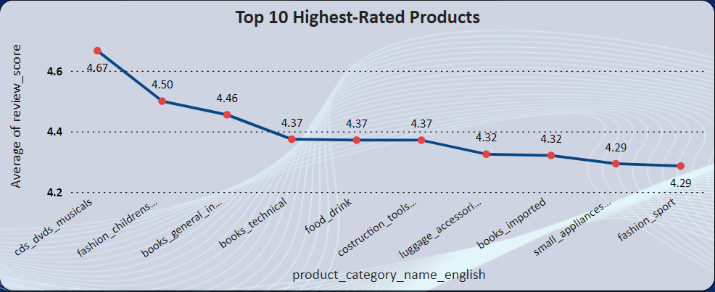**Product Rating Analysis**

The analysis of product ratings is represented through Line chart for the Top 10 highest-rated products. This visual breakdown provides insights into customer satisfaction with different products.

**Key-Insights**

* **Customer Satisfaction** – These visuals help identify which products are most liked by customers based on their ratings.
* **Top-10 Highest Rated Products** – ‘cds_dvds_musicals’, ‘fashion_childrens_clothes’, and ‘books_general_interest’ are the Top 3 products with highest average ratings, indicating high customer satisfaction and potentially strong sales performance. These products can be highlighted in marketing campaigns to attract more customers.
* **Leveraging High Ratings** – Use the information about the highest-rated products to promote them more aggressively. Highlight these products in advertising campaigns and consider using customer testimonials to boost sales.
* **Product Quality** – High Average Ratings suggest good product quality and customer satisfaction.

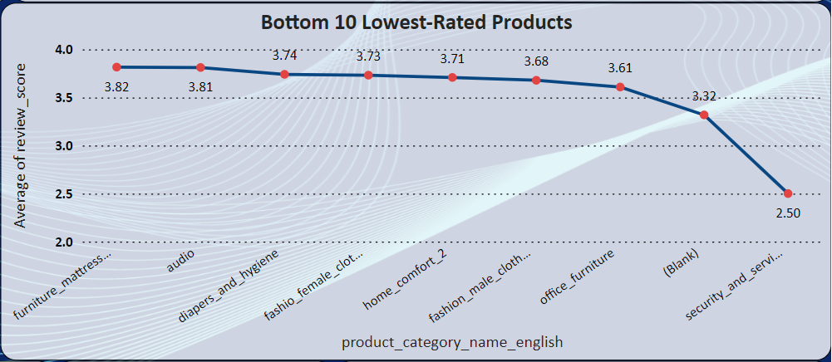

The analysis of product ratings is represented through Line chart for the Bottom 10 lowest-rated products. This visual breakdown provides insights into customer satisfaction with different products.

**Key-Insights**

* **Customer Satisfaction** – These visuals help identify which products are least liked by customers based on their ratings.
* **Bottom 10 Lowest Rated Products** – ‘office_furniture’, ‘security_and_services’, are the Bottom 2 Products with lowest Average Ratings. Suggesting dissatisfaction among customers. This could be due to various factors such as poor quality, mismatch with customer expectations, or other issues.
* **Improving Low Ratings** – Investigate the reasons behind the low ratings for the bottom 10 products. Consider gathering detailed feedback from customers to understand the issues and make necessary improvements. This could involve quality checks, better product descriptions, or enhanced customer support.
* **Product Quality** – Low Average Ratings indicate potential issues with product quality or customer expectations.

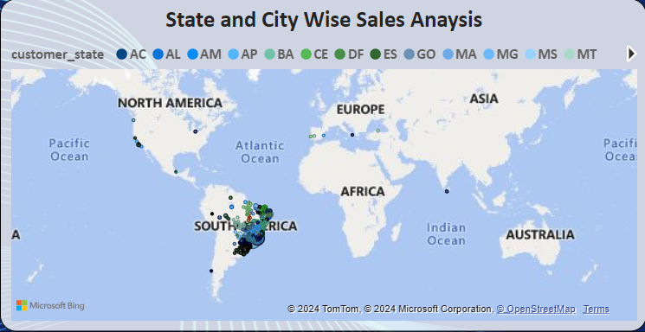**State-Wise Sales Analysis**

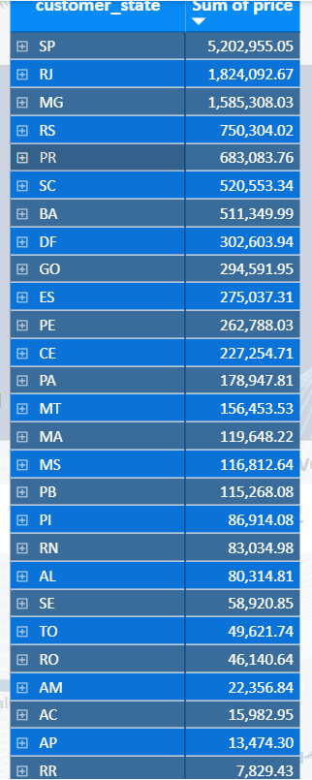

The state-wise sales analysis is represented through a filled map, providing a geographic visualization of sales performance across different states. This helps in identifying regions with high and low sales volumes.

**Visual Elements**

* **Filled Map** – The map shows different states with varying shades of colour, indicating sales volumes.
* **Colour Coding** – Darker shades represent higher sales volumes, while lighter shades indicate lower sales volumes.

**Key-Insights**

* **Regional Performance** – The chart with numbers helps to identify which States are performing well in terms of sales and which are lagging.
* **High Sales States** – ‘SP’ and ‘RJ’ with 5.2M and 1.8M sales, these two Sates are top performing regions, indicating strong market presence and customer base.
* **Low Sales States** – ‘AP’ and ‘RR’ with 13k and 7k are the low performing regions, indicating potential markets for growth and improvement.
* **Focus on High Sales Region** – For states with high sales, continue investing in marketing and customer engagement to maintain and grow the market share.
* **Improve Low Sales Region** – Investigate reasons for low sales in underperforming states. Consider targeted marketing campaigns, localized promotions, and improving distribution channels to boost sales.
* **Resource Allocation** – Allocate resources such as marketing budget and sales teams based on regional performance to maximize ROI (Return on Investment).

**Customer Satisfaction and Retention** – Monitoring customer satisfaction and retention rates across different states helps in understanding customers better. Higher revenue states may indicate stronger customer loyalty and satisfaction, while lower revenue states may require additional efforts to enhance customer experiences and loyalty.

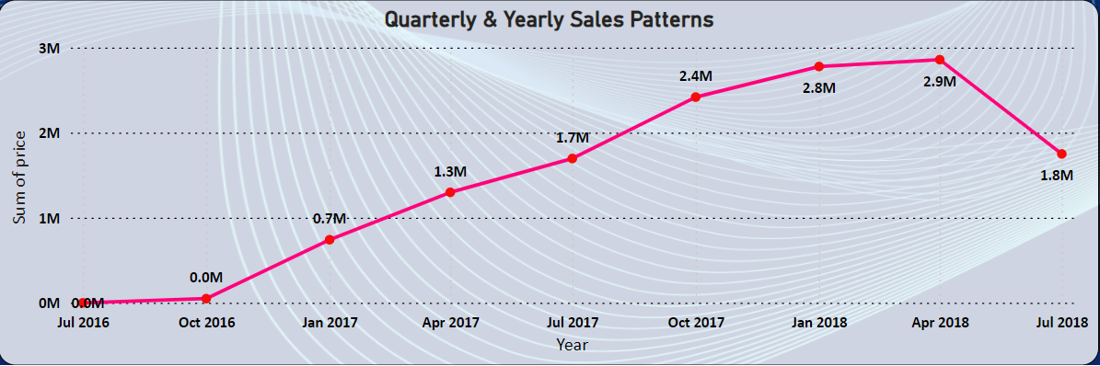**Seasonal Sales Patterns**

The seasonal sales patterns are represented through a line chart, providing a clear visual representation of sales trends across different quarters of the year. This helps in identifying any seasonal variations in sales performance.

**Key-Insights**

* **High Sales Quarter** – The sales peaked in the 2nd quarter of 2018 with a total sum of around 2.9M which is then followed by the 1st quarter of 2018 with a total sum of 2.8M.
* **Low Sales Quarter** – There’s a steady decrease in sales from the 2nd quarter of 2018 which indicates the need for a proper marketing campaign to boost overall sales.
* **Inventory Management** – Use the sales patterns to manage inventory levels, ensuring sufficient stock during high-demand periods and avoiding overstocking during low-demand periods.
* **Resource Allocation** – Allocate resources such as staff, marketing budget, and logistics support in alignment with seasonal sales trends to optimize efficiency and customer satisfaction.

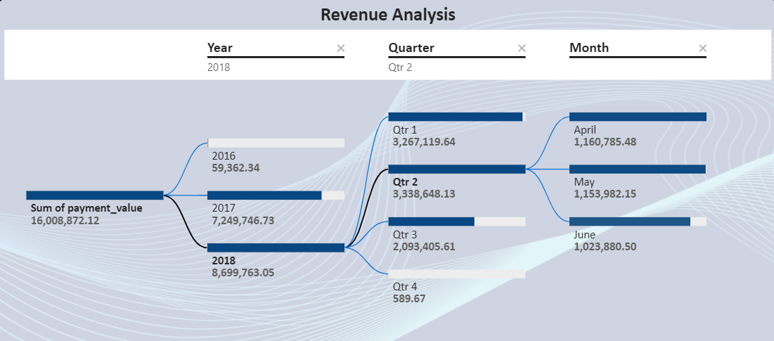**Revenue Analysis**

The revenue analysis is represented through a Decomposition Tree, providing a clear visual representation of total revenue generated over different years. This helps in identifying trends and patterns in revenue growth or decline.

**Revenue Generated in 2016 in 3rd and 4th Quarter.**

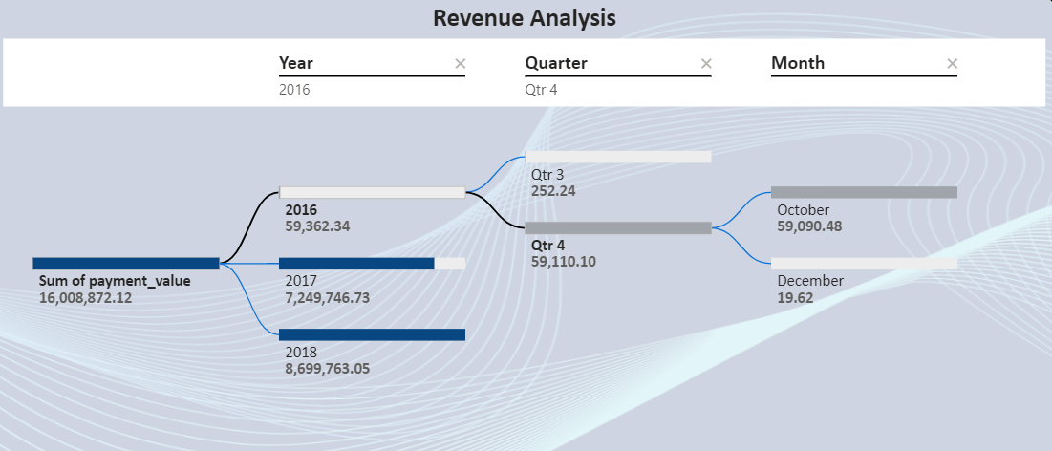

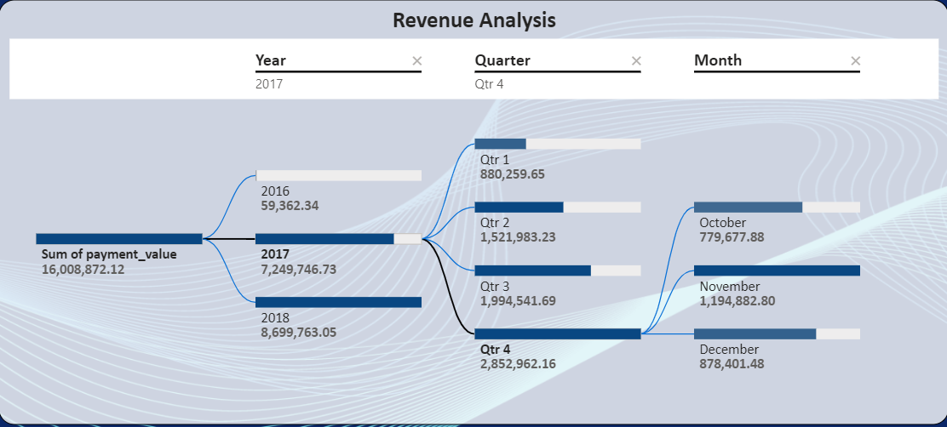**Revenue Generated in 2017**

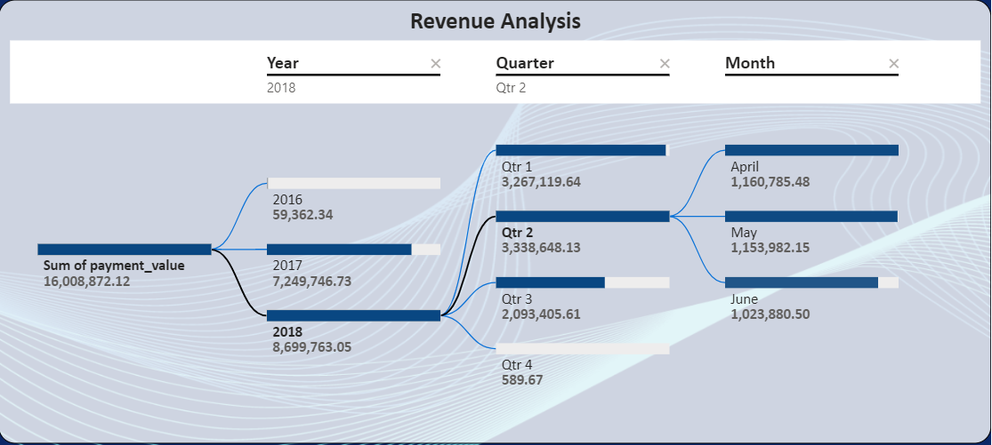 The above Tree shows that we have highest revenue in Quarter 4 of 2017 with almost 2.8M and the lowest in Quarter 1 with 8.8 Lakhs.

The above Tree shows that we have highest revenue in Quarter 2 of 2018 with 3M Lakhs and the Lowest revenue in Quarter 4 of 589.67 Rupees.

**Key-Insights**

* **Highest Revenue** – In 2018 there is a highest revenue of 8M. Indicating successful periods which might be due to effective marketing, product launches, or favourable market conditions.
* **Lowest Revenue** – In 2016 there is a lowest revenue. Suggesting periods of potential challenges or market downturns.
* **Revenue Growth Rate** –

Revenue in 2017 – 7,249,246.73

Revenue in 2018 – 8,699,763.05

1. Difference = 8,699,763.05 – 7,249,246.73 = 1,450,516.32
2. Divide the previous period revenue = 1,450,516.32 / 7,249,246.73 = 0.2
3. Convert to Percentage = 0.2 * 100 = 20%.

The revenue Growth rate from 2017 to 2018 is 20%.

**This report provides a detailed explanation of the Power BI dashboard, including visual representations and insights derived from the data. Each section of the report corresponds to a specific analytical task, visualization, and key findings. The aim is to offer a comprehensive understanding of Shop-Nest’s business performance and support data-driven decision making.**

**Thank You**

SURAJ N D